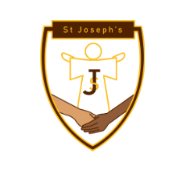
Whole School Curriculum Topic Overview
Term | Y1 - | Y2 - | Y3 | Y4 | Y5 | Y6
Charity  Overarching | Faith | Courage | Solidarity | Practical Wisdom/ Good Sense | Temperance | Justice
Local Topic – History/Geography/Art
Advent | What makes Derby Great?  Home/ SchoolY1  Parks Y2 |  | Why should we be proud of where we live?  Royal Crown Derby Y3  Joseph Wright Y4 |  | How has Derby changed the world?  Richard Arkwright Y5  Rolls Royce Y6
 | Art - Learning From Locals
Learning From Locals  Colour/Paint | Kerry Louise Bennet - King for a Day | Amanda Hughes- Hilltop Lovebirds | Quaker Pegg - Watercolour flowers | Joseph Wright -  Dovedale by Moonlight | Stanfield Moore - The Morledge in Derby | Paul Kenton  Tokyo Brilliance
Scripture/  Spiritual link | "Love is shown by little things, by attention to small daily signs which make us feel at home."  -Pope Francis |  | “We are all one family in the world. Building a community that empowers everyone to attain their full potential through each of us respecting each other’s dignity, rights and responsibilities makes the world a better place to live.” Pope John Paul II |  | Do not conform to the pattern of this world, but be transformed by the renewing of your mind. Then you will be able to test and approve what God’s will is—his good, pleasing and perfect will.  Romans 12:2
DT
CST: Participation | Book Marks  Cutting, folding | Park Equipment  Springs and leavers | Branded Boxes  Nets, folds, joins | Torch/lamps  electrical circuits | Water Wheels  Moving mechanisms | Flying Machines  Lift, drag, weight
History
CST: Human Dignity | What can I remember? | What great people have influenced the way we do things today?  Florence Nightingale | Are humans born to roam?  Stone Age to Iron Age | How does archaeology help us in understanding the past?  Ancient Egypt/Howard Carter | How did the Incas live without money?  Incas | Why do we have the Benin Bronzes and should they be returned to where they came from?  Benin
Scripture/  Spiritual link | ‘And the child grew, strong in spirit, filled with wisdom: and the grace of God was upon him.’ Luke 2:40 | "We who are strong have an obligation to bear with the failings of the weak, and not to please ourselves."  Romans 15:1 | “I am with you and will watch over you wherever you go, and I will bring you back to this land. I will not leave you until I have done what I have promised you.” Genesis 28:15 | Eternal Rest Prayer  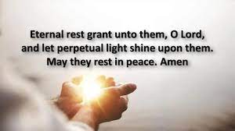 | ‘The world tells us to seek success, power and money; God tells us to seek humility, service and love.’  Pope Francis 2013  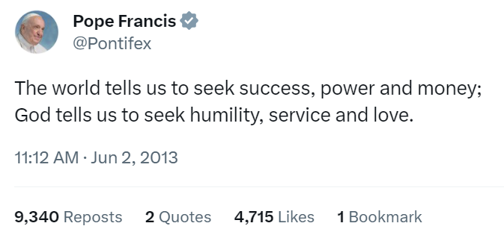 | ‘The future of the human family in a globalised world is along the path of fraternity and social friendship’  Pope Francis  June 2023
Geography
CST: Care for the Common Home | How can we help to care for where we live? | What needs protecting in Derby and Beyond? | Where would you settle in the United Kingdom?  (Rural/Urban) | Why is it important to care for our Rivers?  (Rivers) | Whose responsibility is it to protect the rainforest?  (Amazon) | Should we be concerned about biomes we don’t live in?  (Biomes)
CST: Preferential Option for the Poor | 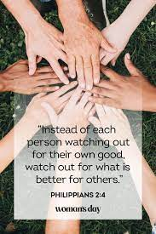 | 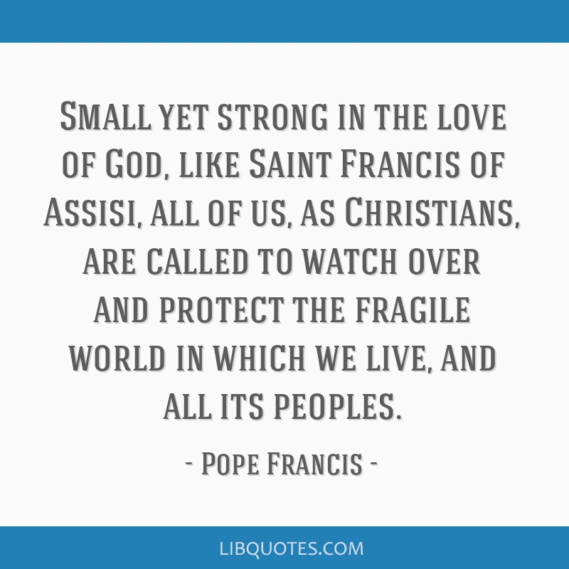 | "Every stranger who knocks on our door is an opportunity to meet Jesus Christ, who identifies himself with the foreigner who has been accepted or rejected in every age”  Pope Francis August 2021’ | ‘You are called to care for creation not only as responsible citizens, but also as followers of Christ!’  Pope Francis  April 2013 | St Thomas Moore  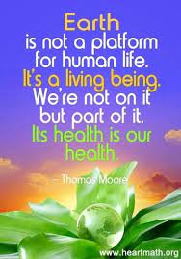 | “God requires that we assist the animals when they need our help. Each being (human or creature) has the same right of protection.” – St. Francis of Assisi
Art in Advent - Faith inspires Art
Advent | Jan Richardson - Wise Women also Came | Jorge Cocco - In the City of David | Jen Norton - Annunciation | Mike Moyers - Host of Angels | Gerard van Honthorst- Adoration of the Shepherds | Angel - Vincent Van Gogh
Geography
Lent  CST: Solidarity | Could you be the next Steve Backshall? | What makes a brilliant city? | Would you live near a volcano? | How is Scandinavia different from Britain? | Local or Global- How should we shop? | What makes a good global neighbour?  (Economic links)
 | 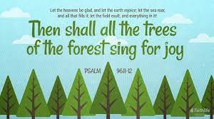  Let the heavens rejoice, let the earth be glad; let the sea resound, and all that is in it. Let the fields be jubilant, and everything in them;  let all the trees of the forest sing for joy.  Let all creation rejoice before the Lord, for he comes, he comes to judge the earth.  Psalm 96 | “There is a need to protect those common areas, visual landmarks and urban landscapes which increase our sense of belonging, of rootedness, of ‘feeling at home’ within a city which includes us and brings us together.”—  Pope Francis | 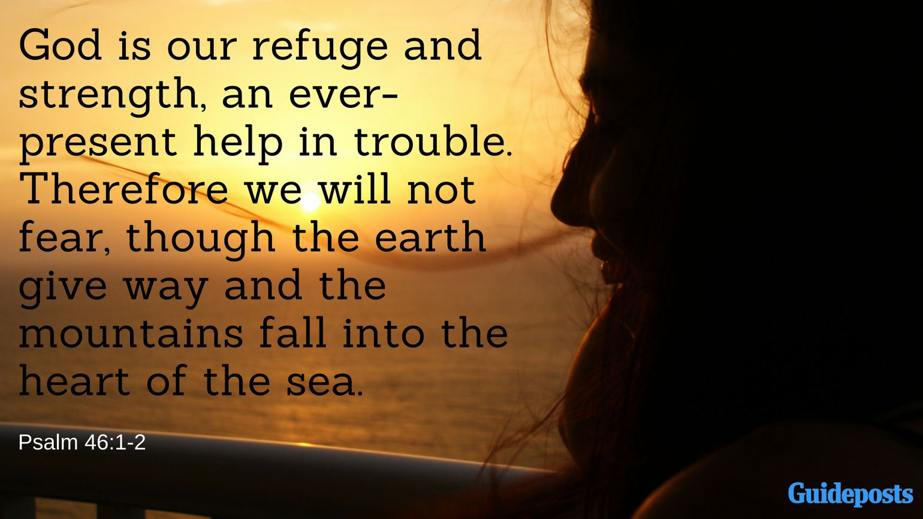  God is our refuge and strength,  always ready to help in times of trouble. So we will not fear when earthquakes come and the mountains crumble into the sea.  Psalm 42 1-2 | 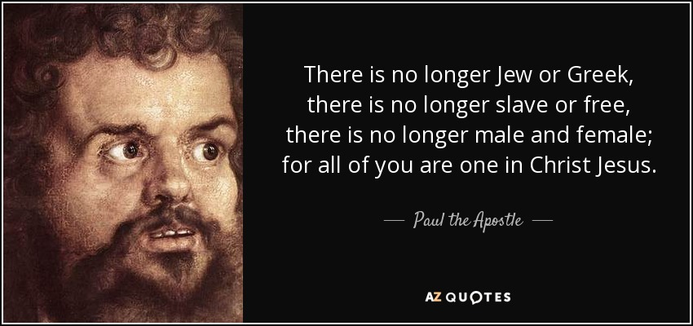  There is no longer Jew or Greek, there is no longer slave or free, there is no longer male and female; for all of you are one in Christ Jesus  St Paul | “Each of us has a personal responsibility to care for creation, this precious gift which God has entrusted to us. This means, on the one hand, that nature is at our disposal, to enjoy and use properly. Yet it also means that we are not its masters. Stewards, but not masters.  Pope Francis | 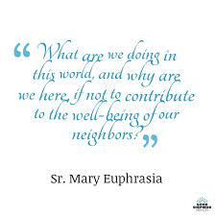  “What are we doing in this world? Why are we here if not to contribute to the salvation of our neighbour?”  Sr. Mary Euphrasia Pellieter
History |  |  | History
Lent  CST: Common Good | How has our school changed? | What has the fire of London taught us? | How did the Romans change Britain? | Is the Viking reputation a worthy one? | Was the industrial revolution worth it?  Victorians/Industrial Revolution | Why should we learn about people in the past?  Ancient Greek
CST: Preferential Option for the Poor | I will instruct you and teach you in the way you should go; I will counsel you with my loving eye on you.  Psalm 32:8 | 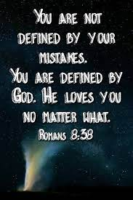 | 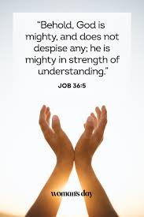 | 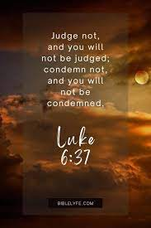 | “Technology that pollutes can also cleanse, production that amasses can also distribute justly, on condition that the ethic of respect for life and human dignity, for the rights of today’s generations and those to come, prevails.” Pope John Paul II | “For everything that was written in the past was written to teach us, so that through the endurance taught in the Scriptures and the encouragement they provide we might have hope” –Romans 15:4.
Religion Inspires Art
Lent | Palm Sunday  Patrick J Murphy | He Qi  Resurrection | Colin McCahon  Easter Morning, | Leonardo Da Vinci Last Supper | Golgotha - Edvard Munch | Picasso  Crucifixion
History
Pentecost  CST: Care for Common Home  CST: Solidarity | Can we fly to the moon?  (History of Space exploration) | Who are the saviours of the Sea?  (RNLI) | How did England get its name?  (Anglo Saxons) | Who was the rightful King?  (1066) | How did Tudor Exploration change the world ?  (Tudor Exploration) | Who are the unsung heroes of WW2?  (WW2)
 | God is more glorious than the moon; he shines brighter than the stars. Job 25:5 | Your road led through the sea, your pathway through the mighty waters— a pathway no one knew was there!  Psalm 77:19 | “Migrants are our brothers and sisters in search of a better life, far away from poverty, hunger, exploitation and the unjust distribution of the planet's resources which are meant to be equitably shared by all. Don't we all want a better, more decent and prosperous life to share with our loved ones?”  Pope Francis | For the LORD is our judge, the LORD is our lawgiver, the LORD is our king; it is he who will save us. .  Psalm 33:22 | Saint Augustine  ‘Men go abroad to wonder at the heights of mountains, at the huge waves of the sea, at the long courses of the rivers, at the vast compass of the ocean, at the circular motions of the stars, and they pass by themselves without wondering.’ | “In difficult moments, I will fix my gaze upon the silent Heart of Jesus, stretched upon the Cross, and from the exploding flames of His merciful Heart, will flow down upon me power and strength to keep fighting.”  St Faustina
Geography
 | What does the world look like from space? | What can I see beside the seaside? | What is great about Great Britain? | Is it time to stop climbing mountains? | Holiday -Home or Away?  North America | Why does the world have borders?  (EU)
 | ‘The LORD merely spoke, and the heavens were created. He breathed the word, and all the stars were born.’  Psalm 33:6 | “the birds in the sky,  and the fish in the sea, all that swim the paths of the seas.  Lord, our Lord,  how majestic is your name in all the earth!”  Psalm 8:8-9 | “We are proud that Catholic schools  promote values that are both Catholic and British, including: respect for the individual, democracy, individual liberty, respect, tolerance and inclusiveness.”  Paul Barber CES 2014 | 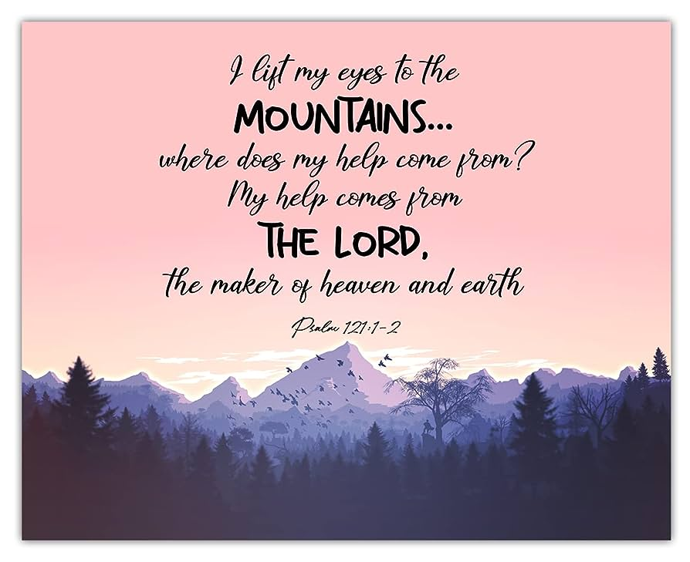 | All Christians need an 'ecological conversion', whereby the effects of their encounter with Jesus Christ become evident in their relationship with the world around them.  Pope Francis | “It is a beautiful thing when borders do not represent boundaries that separate, but points of contact, and when believers in Christ emphasise first the charity that unites us, rather than the historical, cultural and religious differences that divide us.”  Pope Francis April 2023
DT Week |  |  | DT Week
Pentecost | How do we move on the moon?  Wheels and axels | Can you make a boat that floats? | How far can your catapult throw? | Can you make a replica castle? | Can your bridge hold its load? | Can you create a warning alarm?
DT Food – Focus International Day
Pentecost  1. CST: Subsidiarity  2.CST: Human Dignity | Based on country appropriate to the class | Based on country  appropriate to the class | Based on country appropriate to the class | Based on country appropriate to the class | Based on country appropriate to the class | Based on country appropriate to the class
 | Art Week – Depth Study
Pentecost | Frank Bowling – Paint Abstract art | Bridget Riley –  Optical Art | Lynette Yiadom-Boakye – Portrait Art | John Stezaker – Collage/ Conceptual art | Anthony Gromly – Sculpture/Installation art | Peter Blake –  Pop Art

