 | St Joseph’s Catholic Primary School  Handwriting and Presentation Policy | September 2024

MISSION STATEMENT
We are proud of our school as a place of learning, prayer and happiness.
Hand in hand with God, Our Lady and St. Joseph, we promise to work hard and be kind to one another so that we can grow stronger together in faith.
Curriculum Aims
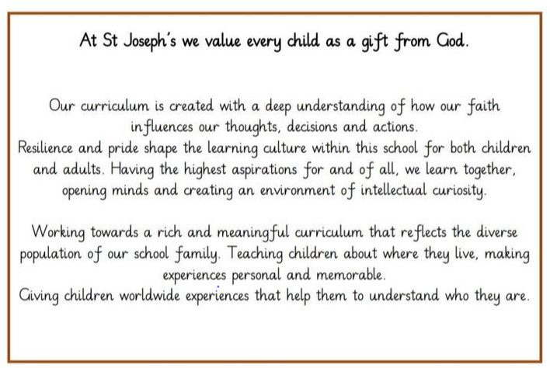
Our curriculum design is based on evidence from cognitive science; three main principles underpin it:
- Learning is most effective with spaced repetition.
- Interleaving helps pupils to discriminate between topics and aids long-term retention.
- Retrieval of previously learned content is frequent and regular, which increases both storage and retrieval strength.

Why is a handwriting policy important for a primary school?

“Handwriting is a skill which, like reading and spelling, affects written communication across
the curriculum. Given effective teaching, handwriting can be mastered by most pupils by the
time they are seven or eight years old enabling them, with practice, to go on to develop a
faster and more mature hand ready for secondary school and adult life. The surest way to
ensure consistent teaching and the development of legible, fluent joined handwriting
throughout the school is to have a written policy agreed and put into practice by all staff.
Handwriting is a movement skill; Children need to practise handwriting movements correctly and often. The first handwriting lessons are vital and the most important issue is to ensure that the children we teach learn to form the letters of the alphabet with the correct sequence of strokes from the beginning. The correct formation of all letters needs to become quite automatic and may require a lot of practice.”

- Suzanne Tiburtius of the National Handwriting Association

Handwriting at St Joseph’s

At St Joseph’s we believe that neat, well-formed handwriting and presentation of written work helps to not only raise standards but also a child’s self esteem as the pupils take pride in and have a sense of ownership of their work. As a school we adopt the Nelson Scheme to teach handwriting.

Aims:
- To raise standards in writing across the school.
- To have a consistent approach across both Key Stage One and Two when teaching handwriting and presentation of work throughout the school.
- To adopt a common approach towards handwriting by all adults when writing in children’s books, on the whiteboard or on displays and resources.

For pupils to:
- Achieve a neat, legible style with correctly formed letters.
- Develop flow and speed, so that eventually they are able to produce the letters automatically in their independent writing.

Entitlement and Curriculum Provision
Handwriting is taught regularly through short, focused sessions 4 times a week and may be linked with spelling, grammar or phonics objectives. Teaching generally occurs outside English lessons, although shared and guided writing also provide additional opportunities for the modelling and monitoring of handwriting.

Teaching and Learning
Handwriting is a skill which needs to be taught explicitly. Since handwriting is essentially a
movement skill, correct modelling of the agreed style by the teacher is very important.
A mixture of whole class, small group and individual teaching is planned.

All members of staff (including teaching assistants, supply teachers, students) are provided
with appropriate handwriting models and are expected to promote the agreed handwriting
style by their own example.

The role of the teacher:
To follow the school policy to help each child develop legible and fluent handwriting.
To provide direct teaching and accurate modelling to ensure consistency across the school.
To provide resources and an environment which promotes good handwriting.
To observe pupils, monitor progress and determine targets for development.

Continuity and Progression

Foundation Stage
Letter formation learned at this early stage becomes automatic and has a profound influence on later fluency and legibility. To aid movement, close attention is given to pencil grip, correct posture, the positioning of the paper and the organisation of the writing space. Teachers are vigilant to ensure that bad habits do not become ingrained and that the specific needs of left-handed pupils (for example, additional tracking and tracing of letters at the pre-writing stage) and those with special educational needs are met.
In the pre-communicative stage pupils play with writing and these experiments are recognised
and praised as an important stage in the child’s understanding that marks on paper convey
meaning. Pupils are given the opportunity to experiment with a range of writing materials and
implements; a multi-sensory approach is used to help pupils feel the movement in the hand.

All Sounds Write phonic sessions will contain an element of writing and this will be modelled by the teacher. When children write teachers will monitor for and encourage correct formation.

Key Stage 1
Building on the Foundation Stage, pupils at Key Stage 1 develop neat legible style handwriting. Correct letter orientation, formation and proportion are taught in line with the school’s agreed handwriting style. This continues in Year 2. By the end of Year 2 children should be able to correctly form the four joins outlined in Nelson.

All Sounds Write phonic sessions will contain an element of writing and this will be modelled by the teacher. When children write teachers will monitor for and encourage correct formation.

Key Stage 2
The target for children in Key Stage Two is to produce a fluent, consistently formed style of joined handwriting with equal spacing between the letters and words.

- Children will have regular handwriting sessions using appropriate prepared resources, in the agreed handwriting style, using the appropriate line guides. This will happen at least 4 times per week (excluding topic weeks)
- Children in Year Three, Year Four and Year Five will write with pencils.
- In Year Six children will have the option to use a handwriting pen.
- Pencils will be used in Maths or for drawing and completion of diagrams.

Presentation Guidance
It is essential that children of all abilities are able to present their work to the highest possible standard increasing their confidence and self-esteem.

- All work must begin with the date. This must be written in the following way:
- Tuesday 10th September 2023. Short date can be used for continuing work and work in Maths lessons
- The date should be written on the top line and underlined with a ruler.
- In Key Stage 1 the date should be written in a form as appropriate for the ability of each child.
- The title should be written in the middle of the next line and underlined with a ruler.
- A line is then missed before starting to write.
- Children should write from the margin to the edge of the page.
- Children must write on the lines.
- Work should be ruled off at the start of the following lesson.
- Children will be encouraged to draw one neat line through mistakes.
- Rubbers will be used within reason to correct pencil work at the discretion of the class teacher.
- Presentation of work expectations will be reminded prior to independent work.
- Pictures should be coloured in pencil crayons. Felt pens should not be used in exercise books.
- When squared paper is used for Maths 1 digit is written in each square.

Resources
To aid pupils’ handwriting we have the whole Nelson Handwriting Scheme in school. The Nelson Font is loaded on all computers in the school so that teaching resources and letters can be produced in the correct font. The Achieving Excellence in Handwriting document can be used to guide planning and progression.

Inclusion
The vast majority of pupils are able to write legibly and fluently. However, some pupils may need more support. Where this is the case a specific individual or group programme will be drawn up in consultation with the Inclusion leader. This will be monitored and reviewed every 6 weeks.

All teachers are aware of the specific needs of left-handed pupils and make appropriate
provision:
- paper should be positioned to the left for right handed pupils and to the right for left
- handed pupils and slanted to suit the individual in either case;
- pencils should not be held too close to the point as this can interrupt pupils’ line of vision;
- pupils should be positioned so that they can place their paper to their left side;
- left-handed pupils should sit to the left of a right-handed child, so that they are not
- competing for space;
- extra practice with left-to-right exercises may well be necessary before pupils write
- left-to-right automatically.

The Learning Environment
There is a dedicated writing area in Foundation and Year 1. Writing areas/boxes are equipped with a range of writing implements and materials.
In Year 2/KS2 suitable materials are available for pupils to work at their own tables.
Throughout all Key stages teachers display both handwritten and word processed work to give a high profile to developing a neat, legible cursive style

The Role of Parents and Carers
The Foundation Stage teachers play an important role in communicating this at an early
stage, for example, to ensure that parents are informed and encouraged to offer good models
to their pupils by using only capital letters for the beginning of their names, practising
drawing patterns together, playing joining up games which encourage left to right
directionality.

Parental workshops will be held regularly to advise parents on the curriculum and these include the school policy for the teaching of handwriting. If a child needs additional intervention to support their handwriting development parents are informed and resources for extra practise are sent home.

Monitoring and Evaluation
- This will be undertaken by the class teacher and issues will be dealt with during quality first teaching or required intervention.
- When undertaking work scrutinies, the Senior Leadership Team, subject co-ordinators and governors will monitor written work for neat presentation and the use of cursive writing.

