 | St Joseph’s Catholic Primary School  English Policy | September 2024

MISSION STATEMENT
We are proud of our school as a place of learning, prayer and happiness.
Hand in hand with God, Our Lady and St. Joseph, we promise to work hard and be kind to one another so that we can grow stronger together in faith.
Whole School Curriculum Intent

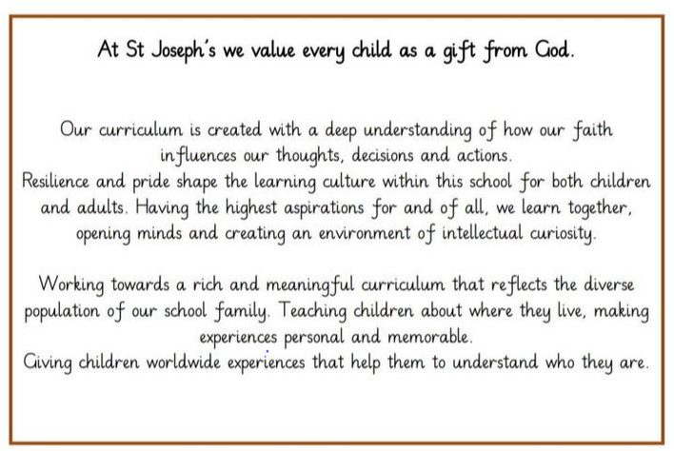
Our curriculum design is based on evidence from cognitive science; three main principles underpin it:
- Learning is most effective with spaced repetition.
- Interleaving helps pupils to discriminate between topics and aids long-term retention.
- Retrieval of previously learned content is frequent and regular, which increases both storage and retrieval strength.

English Intent
We aim to develop pupils’ abilities within an integrated programme of Speaking & Listening, Reading & Writing. Children are given opportunities to interrelate the requirements of English through the Talk for Writing approach and within planned opportunities to reinforce and consolidate skills across the curriculum.

At St. Joseph’s we strive for children to:
- read and write with confidence, fluency and understanding, using a range of independent strategies to self- correct.
- develop a habit of reading and read for enjoyment and information
- have an interest in words and their meanings; acquiring a wide vocabulary in spoken and written forms
- appreciate our rich and varied literary heritage.
- understand a range of text types and genres, adapting their language to write in a variety of styles for a range of contexts, purposes and audiences.
- have a technical understanding of grammar and punctuation.
- are developing the powers of imagination, inventiveness and critical awareness.
- explore, develop, sustain and explain ideas and understanding through talk.
- participate in speaking and listening activities such as formal presentations and participating in debates.

Teaching and Learning

Throughout English teaching the pitch and pace of the learning is sensitive to the needs of the children. Teachers have high expectations enabling all children make progress by following a clear Sequence of Teaching through Talk for Writing. The strong interdependence between speaking, listening, reading and writing underpins planning and provision for learning. English teaching starts with a ‘hook’ to engage and enthuse children to learn. English teaching is organised into units of 3 week blocks and each unit builds on the skills the children have learnt previously. ‘Talk for Writing’ allows children to build on and develop key oracy skills before writing independently. Drama activities are also regularly planned for and are used to develop key learning objectives.

Teachers plan in teams to ensure continuity and progression across year groups.

Usually children work in a range of groups. Tasks are set at a suitable challenging level and adult support is given as necessary. Children may also work in mixed ability groups on collaborative tasks.

At St. Joseph’s we see the learning environment as a crucial tool to support our children to develop their reading and writing skills. Working walls, washing lines and toolkits support and promote independent learning. Working walls support learning about features of particular genres that are used during units of work. The teacher models effective use of the working walls during modelled and shared writing.

Multisensory phonics and spelling strategies are used with children along with developing an investigative approach to spelling patterns and conventions. In KS1 children have a daily phonics session following the Sounds Write program and in KS2 children have a spelling session at least twice a week following the Sounds and Syllables scheme. Grammar and punctuation are taught discretely and in context. Daily ‘Writing Burst’ sessions provide opportunities for children to be taught a specific skill and to practise it. These skills are then applied in context during English lessons.

Early Years Foundation Stage
In the Foundation Stage children are given opportunities to:
- speak and listen and represent ideas in their activities;
- use communication, language and literacy in every part of the curriculum;
- become immersed in an environment rich in print and possibilities for communication.
- see adults writing for children
- experiment with writing for themselves through making marks, personal writing symbols and conventional script

The Early learning Goals are followed to ensure continuity and progression from the Foundation Stage through to the National Curriculum.

Key Stage One (Years 1 and 2),
At KS1 children are given opportunities to;
- speak confidently and listen to what others have to say.
- begin to read and write independently and with enthusiasm
- use language to explore their own experiences and imaginary worlds.
- write for a range of different purposes

Key Stage Two (Years 3,4,5 and 6)
At KS2 children are given opportunities to;
- change the way they speak and write to suit different situations, purposes and audiences.
- read a range of texts and respond to different layers of meaning in them.
- explore the use of language in literary and non-literary texts and learn how the structure of language works.

Teaching of Spoken Language
“Spoken language underpins the development of reading and writing.” (National Curriculum 2014)

At St. Joseph’s, children are encouraged to develop confident and competent communication skills to support their reading and writing and in readiness for later life. During the sequence of teaching, teachers use a range of techniques to support progression through speaking and listening.
These include
- oral and mental starters – listening/speaking games and activities
- talking partners
- hot seating/freeze framing
- drama and role play
- oral rehearsal

Teaching of Writing
“Children need to experience language being used in order to be able to use it effectively themselves.” (Primary Framework 2006)

During the sequence of teaching a range of techniques are used to support the progression and accumulation of skills in writing. Children learn to convey meaning through grammatically correct and correctly punctuated sentences. Teachers use a range of resources to support planning for this.
Talk for Writing – immersing children in language and word games, oral rehearsal through story/text maps or use of the washing line approach, using drama and other speaking and listening activities
Emergent writing
Demonstration writing – this is a crucial tool for developing writing
Shared Writing /supported composition - sentences or short paragraphs are demonstrated and then imitated
Guided Writing - a small group working on a specific area of writing with adult guidance
Independent Writing - children following the model from the whole class work with clear expectations
Children are encouraged to take pride in the presentation of all of their work.

Spelling and Grammar
Spelling and grammar is explicitly taught in daily writing burst sessions. For grammar input teachers must follow the ‘Progression in Grammar’ document which identifies key grammar teaching in each academic year. Spelling is taught following the ‘Sounds and Syllables Scheme’.

Cross-curricular Literacy Opportunities
Teachers seek to take advantage of opportunities to make cross-curricular links. They plan for pupils to practise and apply the skills, knowledge and understanding acquired through literacy lessons to other areas of the curriculum. Medium term planning identifies opportunities for where these key Literacy skills can be applied. Opportunities to use ICT to support teaching and learning in Literacy are planned for and incorporated into the daily lesson as appropriate, e.g. using film clips and adverts as a stimulus for writing.

Marking and Feedback
Literacy books are marked in accordance with the marking policy. Books are highlighted in green, showing success against success criteria, with additional comments made in green pen to encourage and improve. Peer and self-marking also takes place within Literacy lessons.

Assessment and Target Setting
Children are assessed using the APP (Assessing Pupil Progress) guidelines for reading and writing. Assessments are made through warm-up activities, guided reading and writing and independent reading and writing activities which demonstrate their skills in literacy. Moderation meetings are held to support colleagues in making judgements. In Years 1-6 children are assessed and levelled each term and next steps are identified.

Children have individual or group targets which they work towards. Children work through a range of targets at their own pace.

Inclusion
We aim to provide an inclusive learning experience for all children so that they achieve as highly as they can in other areas according to their individual abilities. We identify which pupils or groups of pupils are under-achieving and take steps to improve their attainment. Planning for individual children or groups of children based on the Assessment of learning. For the majority of the time it will be appropriate for children to work on objectives that are similar and related to the whole class. However, at other times you will also have to consider whether the children have other priority needs that are central to their learning, for example a need to concentrate on some key skills. Stretch children are identified and suitable learning challenges provided.

Equal Opportunities
All children are provided with equal access to the English curriculum. We aim to provide suitable learning opportunities to reflect our diverse culture. Further support or adaptation of resources is provided for children to help access the curriculum.
Identified EAL children are given additional support to work towards their language development targets.

Role of the Subject Leader
The Subject Leader is responsible for improving the standards of teaching and learning in Literacy through monitoring
- pupil progress (work scrutiny, pupil interviews and reading /writing levels)
- provision of Literacy (including Intervention and Support programmes)
- Auditing and supporting colleagues in their CPD (e.g. agreement trialling, team teaching, peer coaching, planning support, planning for layered targets)
- Purchasing and organising resources
- Keeping up to date with recent Literacy developments
- Analysis of assessment data

The Governing Body
Reports are made to the Curriculum Committee regarding the performance targets and key areas of development for each key stage. This policy will be reviewed every three years or in the light of changes to legal requirements.

