Dear Parents / Carers

We are having a Christmas jumper /sparkly dress sale at the Christmas market. We would love for you to donate sparkly old dresses, old Christmas jumpers and any other Christmas clothes. They would have to be in good condition which means they would have no tears and must be clean.
Your child will have to give them to their class teachers by Monday December 6th. The sale will be at the Christmas fair on Wednesday 8th December from 3pm until 5pm. If you want to buy the clothes they will cost 50p and we will donate this money to CAFOD.

Please support us in our Eco Warrior message - REUSE, REDUCE and RECYCLE

From Fnan, Helen and the Eco Warrior team.

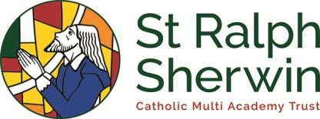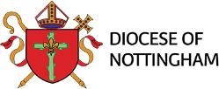
St Joseph’s Catholic Voluntary Academy

Mill Hill Lane, Derby, DE236SB

Tel: 01332 361 660 |
admin@stjosephs.derby.sch.uk

www.stjosephscatholicpri.co.uk

