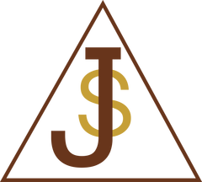  St Joseph’s Catholic Primary School  School Uniform Policy | Policy No B22
Issue No 2
July 2016

Mission Statement
We are proud of our school as a place of learning, prayer and happiness.
Hand in hand with God, Our Lady and St. Joseph, we promise to work hard and be kind to one another so that we can grow stronger together in our faith.
St. Joseph's School strives to enable every child to reach their own potential. Whilst we are proud, and rightly so, of our academic achievements, which continue to be among the best in the City, developing the whole child is equally, if not more important.
It is the firm belief of the Governors that wearing a uniform gives an essential unity, cohesiveness and family feeling to our school helping build children's self-confidence as well as nurturing a sense of pride in belonging to the school. Therefore the wearing of school uniform is compulsory and we expect our children to maintain a smart appearance during the school day. Fashions may change but we expect our children to present themselves at all times in a conventional style. Decisions on what is acceptable will be made by the Head Teacher. If you are in any doubt please contact her at the school.
Best Value
St. Joseph’s School is committed to ensuring that uniform will be affordable for all parents and does not act as a barrier to parents when choosing the school. The majority of the uniform is available online from our carefully sourced suppliers at a competitive price (for more information on our supplier please speak to the school office staff).

Outer clothing (coats etc) may be of any style reducing uniform costs and allowing for bright colours to be worn for safety reasons.

To ensure that any lost clothing can be returned easily to the owner, it is strongly recommended that all uniform and outdoor clothing is named clearly. Each year hundreds of pounds worth of clothing is lost when children cannot find garments as they have no name on them.

Health and Safety
- The school expects that long hair is tied back to avoid accidents. Large headpieces are not appropriate. Small hair accessories should be in school colours.
- Boys are expected to have a tidy hair cut with no tram-lines or markings cut into the hair or shaving of the head as this is not an appropriate school style and may appear threatening to some. Tidy ‘plaiting’ styles reflective of culture are acceptable. Coloured hair extensions are not appropriate.
- Jewellery must not be worn although Year 6 children may wear a watch and girls with pierced ears may wear studs. These MUST be removed for PE on every occasion, even if the ears are newly pierced. We recommend that piecing is carried out in the Summer holidays to allow time for the holes to heal. It is not possible to sign a form accepting responsibility for any accident if children continue to wear earrings as the danger may be to other children in stepping on a stud etc.
- Sensible shoes with low heals and firm strapping or ties to avoid slips and falls. Boots / ankle boots are not appropriate footwear.

Ethnic and Religious/Disability Considerations
- Girls are allowed to wear trousers in order to achieve required modesty. Any other requests will be discussed by Personnel Governors on an individual basis.
- Consideration will be taken for those children who need to wear particular fabrics or styles due to medical/ physical conditions e.g. need to wear particular fabrics for skin conditions or special shoes due to problems with feet.

Children Not Wearing Appropriate Uniform
- Attempts will be made to find out the reason for uniform code (including PE) not being adhered to and problems addressed.
- In extreme cases where parents have been involved in discussion with the Head Teacher and a child has returned to school without correct uniform, the parents will be asked to take the child home or come to school immediately to sort out correct attire.

School Dress Code
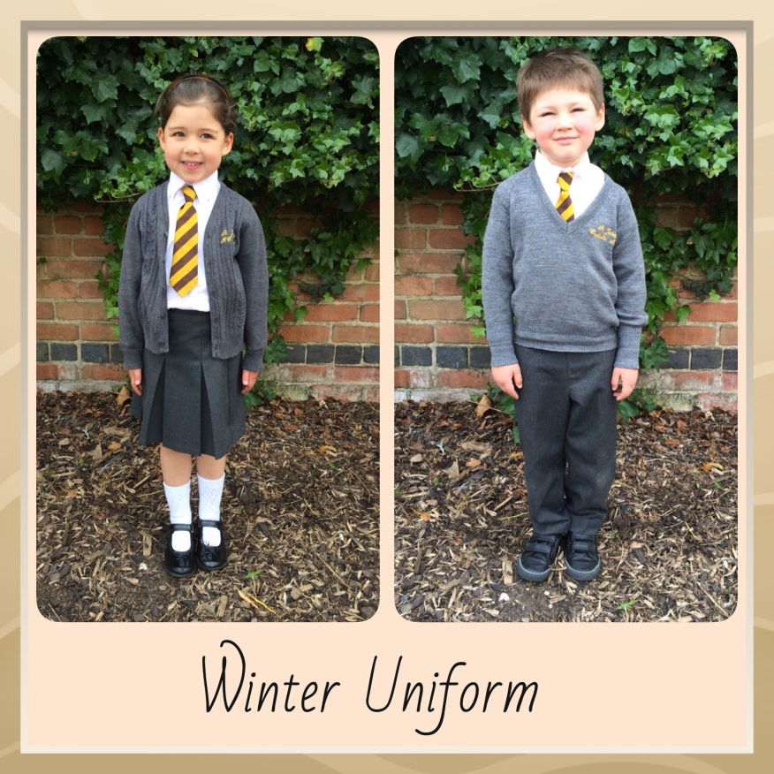
Winter uniform is worn after the first half term of a new school year (October/November) up until the Easter holidays, and should consist of:

- Grey trouser or grey skirt or pinafore. Girl’s attire must be of a modest length.
- White shirt
- School tie (brown and gold)
- Grey knitted jumper or knitted cardigan, these must be embroidered with the St Joseph’s emblem.
- Black shoes
- Grey sock or tights. White socks can be worn instead of tights.

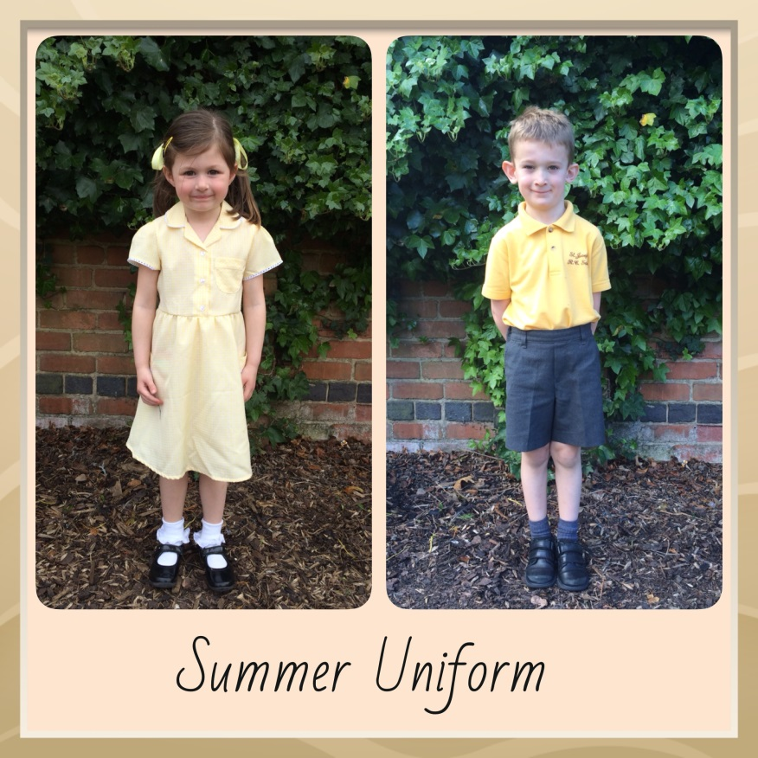
Summer uniform is worn after the Easter holidays and up until the first half term of a new school year. It should consist of:
Boys

- Grey shorts or trouser
- Yellow embroidered t-shirt.
- Knitted jumper
- Black shoes
- Grey socks
Girls
- Yellow gingham dress. Once girls reach Y5 they can wear a yellow embroidered t-shirt with a grey skirt of modest length. Cycling shorts are not permitted under the dresses except for break times.
- Grey embroidered cardigan
- White socks, white tights can be worn during the cooler months.
- Black shoes
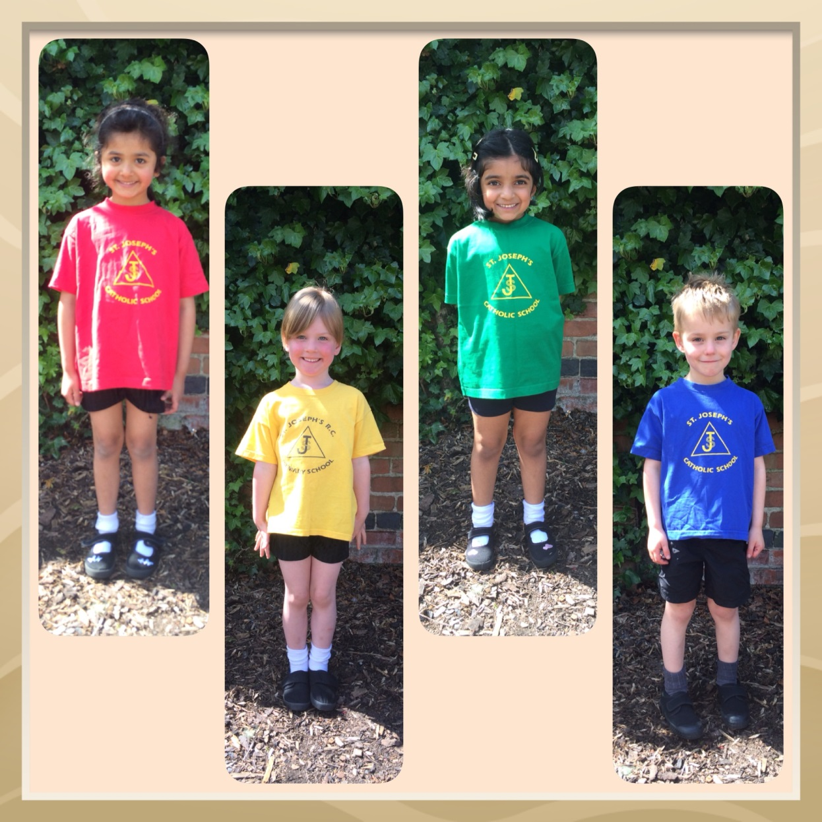
PE Kit
Indoor

- Black shorts
- PE T-shirt in house colours

- Black pumps

Outdoors
- PE t-shirt in house colours
- Black tracksuit bottoms
- Sweatshirt in house colours
- Outdoor trainers

PE bags should be purchased in house colours

Other uniform items:
Brown book bags with school emblem. These must be used by FS2 and KS1 children. Brown school rucksacks can be purchased for older children.
Hats, coats and fleeces can be purchased in school colours from our suppliers.

Signed: ___________________________ Date: 21st July 2016
Chair of Governors

Signed: ___________________________ Date: 21st July 2016
Head Teacher

Date to be reviewed: 21/07/2017

